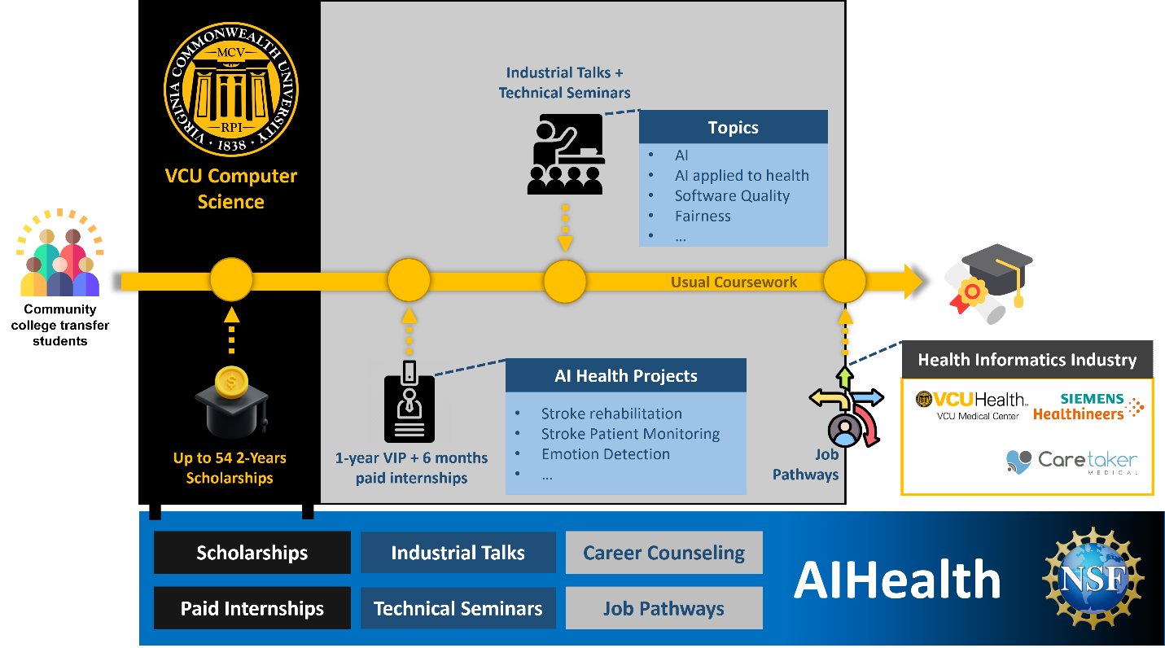

**Timeline and Program Flow**

1. **VCU Computer Science Start Point**  
   Community college transfer students begin their journey in the Computer Science program at VCU.
2. **Scholarships**
   * Up to **54 scholarships** for 2 years are available, providing financial support to students.
   * This ensures access to resources for a diverse group of students.
3. **Coursework and Enrichment**
   * Students engage in **usual coursework**, enhanced by:
     + **Industrial Talks** and **Technical Seminars** on topics such as:
       - Artificial Intelligence (AI)
       - AI Applied to Health
       - Software Quality
       - Fairness, and more.
4. **AI Health Projects**
   * Students participate in **AI Health Projects**, addressing real-world challenges like:
     + Stroke Rehabilitation
     + Stroke Patient Monitoring
     + Emotion Detection
   * Projects are supported by a 1-year **VIP (Vertically Integrated Projects)** and an additional **6-month paid internship** to provide experiential learning.
5. **Career and Industry Connections**
   * A pathway connects students to the **Health Informatics Industry**, with partners including:
     + VCU Health (VCU Medical Center)
     + Caretaker Medical
     + CS PhD Program at VCU
   * These partnerships provide **job pathways** for graduating students.

**Support Mechanisms**

At the bottom, the image highlights the following support structures for students:

* **Scholarships**: Financial aid for qualifying students.
* **Paid Internships**: Hands-on industry experience.
* **Industrial Talks**: Exposure to industry leaders.
* **Technical Seminars**: Skill-building workshops.
* **Career Counseling**: Guidance for long-term professional development.
* **Job Pathways**: Direct connections to careers in AI and health-related industries.

**Key Highlights**

* Collaboration between **academia and industry** for impactful education.
* Focus on **real-world AI applications in health**.
* Integration of financial, educational, and career support to ensure success.

This structured pipeline ensures students gain knowledge, experience, and industry connections, preparing them for successful careers in AI for Health.